

Project Name: Sahyadri Navigator

Branch PG-DAC September-2023

Documentation On

**“**Sahyadri Navigator**”**

PG-DAC September 2023

**Guided By: Dipali Jadhav**

Submitted By :

**Group No: 06**

**Dhanshri Kshirsagar [2309043020026]**

**Meghana Bharambe [2309043020057]**

**Supriya Sutar [2309043020095]**

**Sumit Patil [2309043020094]**

# Table of Contents

1. **Introduction .........................................................................................................................4**
   1. Document Purpose ...........................................................................................................**4**
   2. Project Background ..........................................................................................................**4**
   3. Aim & Objectives ............................................................................................................ **4**
2. **Business Requirements Overview**…………………………………………………………**5**

**3.Functional Requirements** .....................................................................................................**5**

* 1. Admin Module .................................................................................................................**5**
  2. Trekker Module ................................................................................................................**6**
  3. Trekking Club Module .....................................................................................................**6**

1. **Non-Functional Requirement……………………………………………………………..6**

1. **Use Case Diagram ............................................................................................................... 7**
   1. Admin .............................................................................................................................. **7**
   2. Trekker ............................................................................................................................. **8**
   3. Trekking Club ...................................................................................................................**9**

6. **Database Design ................................................................................................................... 10**

* + 1. Login ................................................................................................................................. **10**
    2. Role……………………………………………………………………………………….10
    3. TrekkerRegistration.............................................................................................................**10**
    4. Trekking Club………………………………………………………………………………………………………………….11
    5. Trekking Details………………………………………………………………………………………………………………11
    6. Trekking Location…………………………………………………………………………………………………………….11
    7. Trekk Facility…………………………………………………………………………………………………………………….12
    8. BookTrekk…………………………………………………………………………………………………………………………12
    9. Image………………………………………………………………………………………………………………………………...12
    10. Payment…………………………………………………………………………………………………………………………….13

1. **E-R Diagram……………………………………………………………………………………… 19**
2. **Snapshots ............................................................................................................................ 20**
3. **Conclusion .......................................................................................................................... 27**

# List of Figures

**Use Case Diagrams ............................................................................................................ 17**

Fig 1 Admin ........................................................................................................................... 8

Fig 2 Trekker ........................................................................................................................... 10

Fig 3 Trekking Club.................................................................................................................. 12

# 1. Introduction

## 1.1 Document Purpose

## Sahyadri Navigator Trekking Management serves as a comprehensive guide and reference for the planning, execution, and supervision of trekking activities. The purpose of this document is to ensure the safety, efficiency, and overall success of trekking ventures. It typically includes various components and information to address different aspects of trekking management.

## 1.2 Project Background

There is no system available for trekkers to find upcoming trekking events. Currently, the trekkers go to the nearest trekking club and check for the upcoming trekking events. For this they have to search a lot.

After visiting different trekking clubs sometimes they don’t find any club who can fulfill their expectations. It is difficult for them to compare between those clubs to get perfect club with various aspects such as timing, price, guidance, etc.

## 1.3 Aim & Objective

* The main objective of this project is building a website which will help trekkers from different places to find trekking spot.
* Trekkers can find best suitable option from multiple trekking clubs which have registered on our platform.
* They can go through multiple options and according to their preferences (time, place, price and other facilities) they can select suitable choice.
* Different Trekkers club can register on our platform and can put their next schedule about their trekking events.

## 1.4 Customers and Stakeholders

Customers:

* + - * Admin
      * Trekkers
      * Trekking Clubs

Stakeholders:

* + - * Trekking Community.
      * Youth interested in Trekking
      * Tourism Industry
      * Government(Ministry of Tourism)

# 2. Business Requirements Overview

* Sahyadri Navigator is the public web application.

* Sahyadri Navigator will be opened to the India, but in the phase 1, the main target is in the Maharashtra.

* There are mainly three types of users. One is the Admin other is Trekker and third one will be Trekking Club.

* Trekker can showcase their interest on this platform and they can complete their dream of exploring the treks on this web application.

* Trekking Club can publish their upcoming treks.

* Sahyadri Navigator provides function which connects the Trekker and Trekking Clubs efficiently.
* Sahyadri Navigator could be maintained by Admin.

# 3. Functional Requirements Overview

Sahyadri Navigator consists of Three modules described as below.

1. Admin Module
2. Trekker Module
3. Trekking Club Module

## 3.1 Admin Module

* Sahyadri Navigator should provide all function to admin how to handle the System.

* Admin will Manage the Trekker (Delete).
* Admin will Manage the Trekking Club (Approve, Delete)

* Could able to know all the Transaction.

3.2 **Trekker** Module

* Trekker can register and create his own account.

* Sahyadri Navigator provides the function which allows Trekker to find out the information about Trekking Clubs and upcoming trekks
* Trekker can Book the trekks and check the booked trekks.
* Trekker can view the profile and edit profile.

## 3.3 Trekking Club Module

* Trekking Club can register and create his own account.

* Sahyadri Navigator provides the function which allows Trekking Club to Add the trekks and publish his upcoming trekks.

* Trekking Club can check the History that which trekker registerd for which trekk and his details.

# 4. Non-functional Requirements

* The website should use professional design, look and feel and color scheme.
* Users will have no limitations for accessing the application through Internet. The portal being an internet application, it is difficult to specify exact number of visitor or users. Hence we will target the system to support between 5 and 10 million users on launch of phase 1.
* Being a public website, the site must follow general usability guidelines for menus, navigation, colors, links and other actions provided on the screens.
* The system should be designed in such a manner that user will be able to complete tasks in minimum number of steps.

.

# 5. Use Case Diagram

**Admin:**

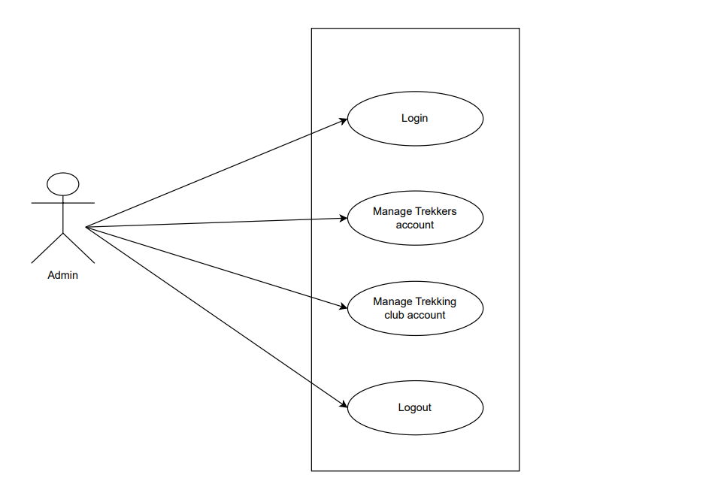

*Fig. Use case diagram for admin*

**Admin:**

1. In Admin use case diagram Admin is the Actor.
2. Admin can handle following use cases:
   1. Login
   2. Manage Trekkers account
   3. Manage Trekking Club account
   4. Logout

**Trekker:**

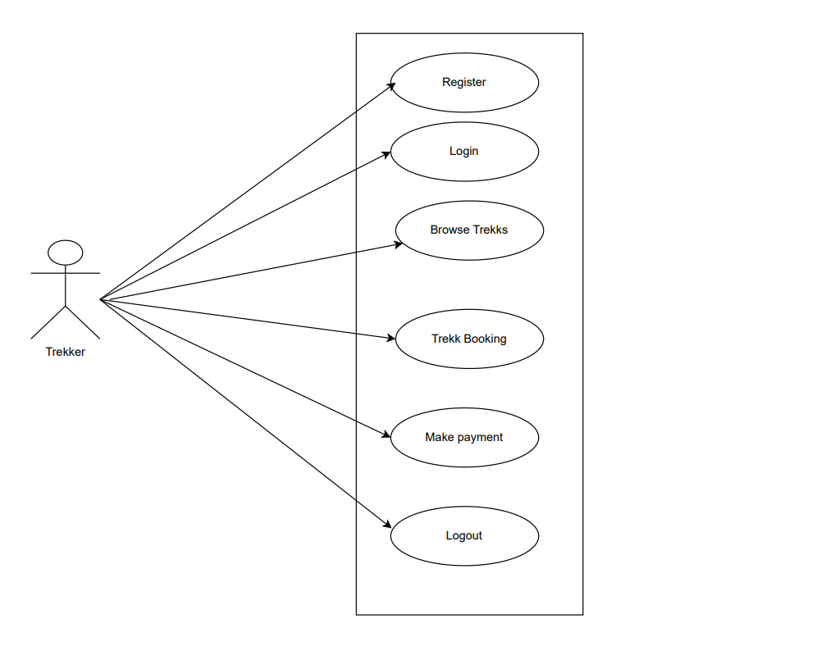

*Fig. Use case diagram for Trekker*

**Trekker:**

1. In Trekker use case diagram Trekker is the User.
2. Trekker can handle following use cases:
   1. Register
   2. Login
   3. Brows Trekk
   4. Trekk Booking
   5. Make payment
   6. Logout

**Trekking Club:**

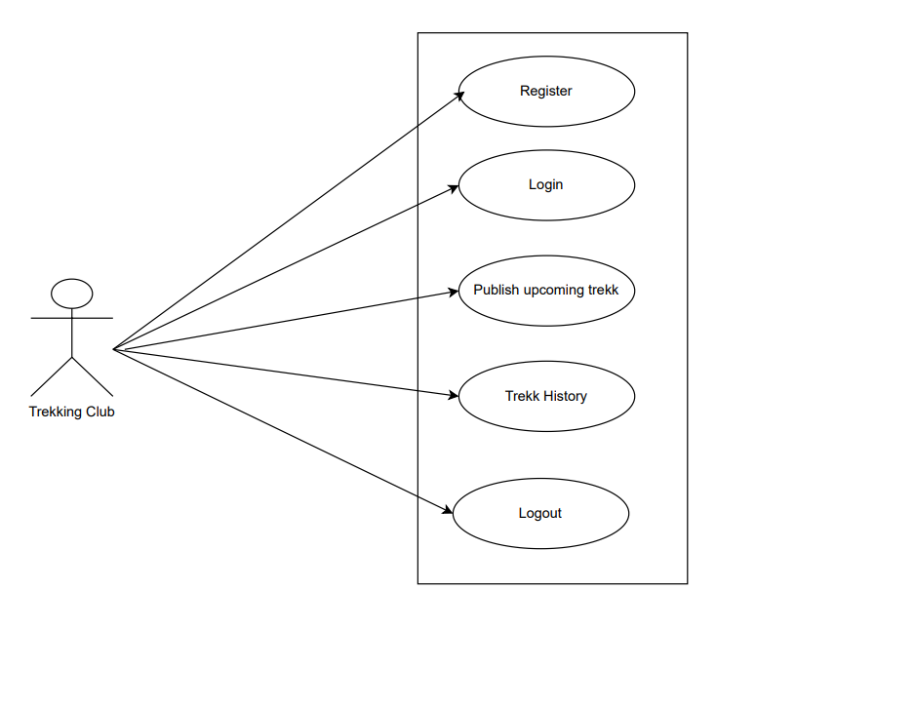

*Fig. Use case diagram for Trekking Club*

**Trekking Club:**

1. In Trekking Club use case diagram Trekking Club is the User**.**
2. Customer can handle following use cases:
   1. Register
   2. Login
   3. Buy Product
   4. Payback
   5. Cancel Order

**6. Database Design:**

## 1] login table

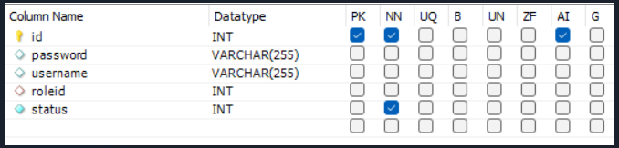

## 2] role table

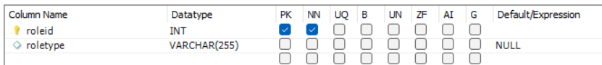

**3] User**

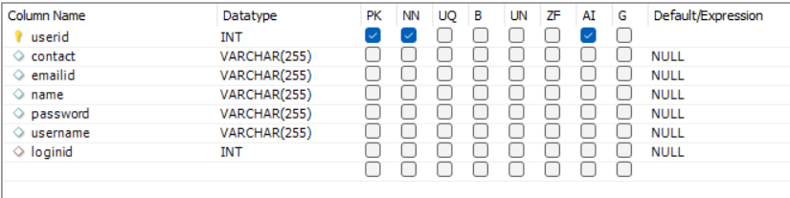

**4] Trekking Club**

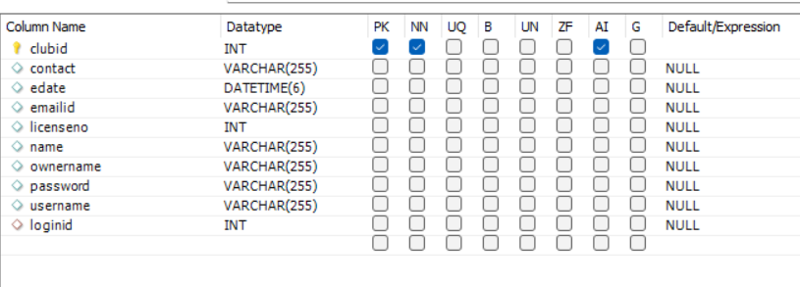

**5] Trekk Details**

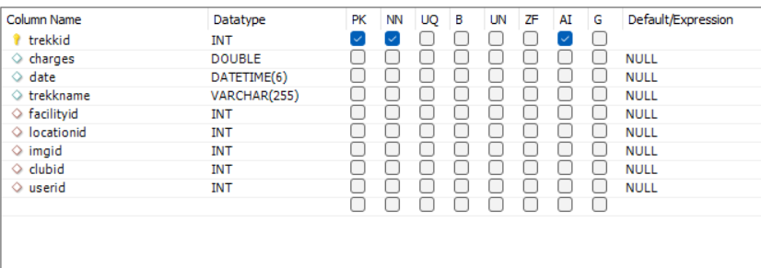

**6] Trekk Location**

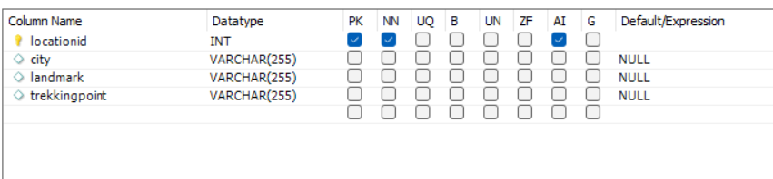

**7] Trekk Facility**

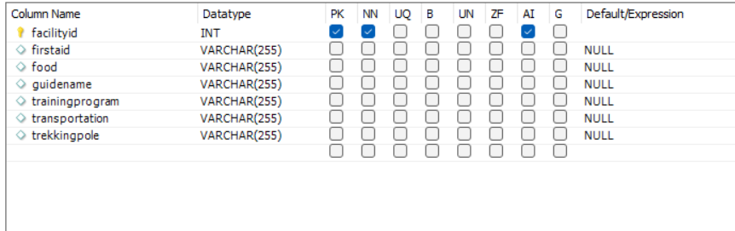

**8] Book Trekk**

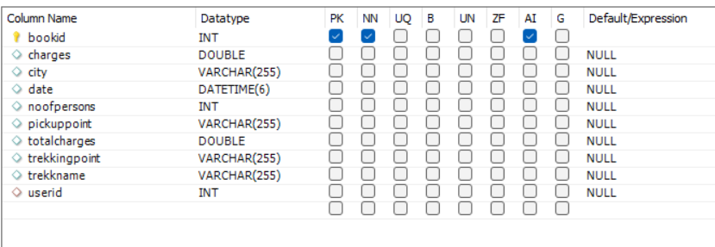

**9] Image**

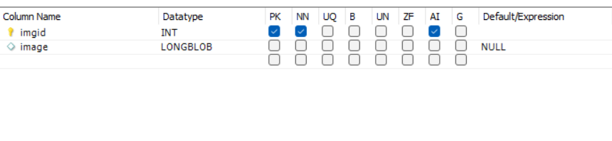

**10] Payment**

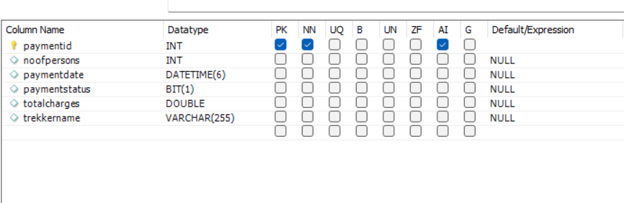

1. **Snapshots:**

* 1. **Home Page:**

Following snapshot shows the Home page for Sahyadri Navigator before Login.

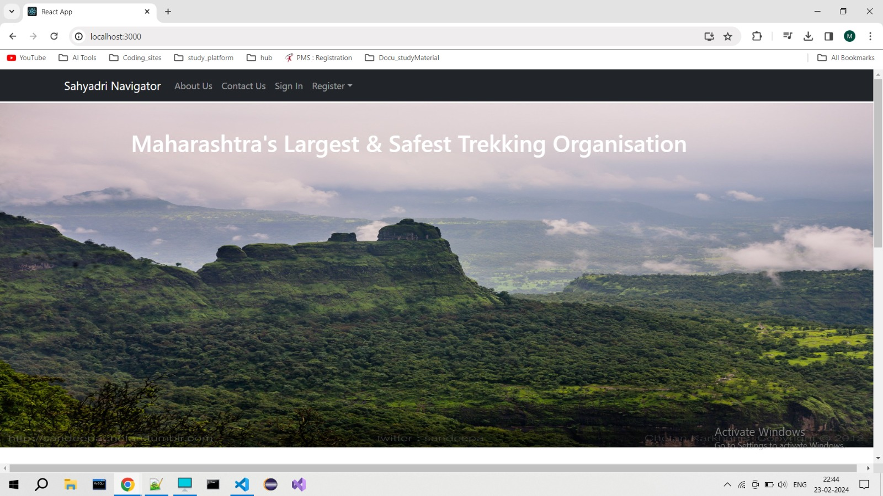

Home page contains Upcoming treks and feedback and other details about the website.

* 1. **Registration Page:**

Trekker Registration page:

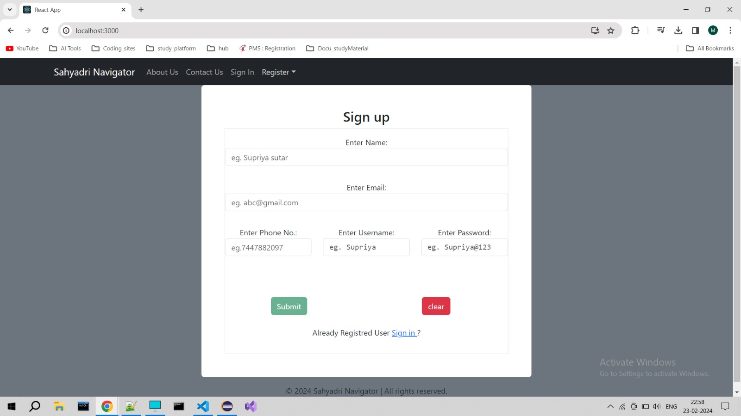

Similarly, there is Registration page for Trekking Club .

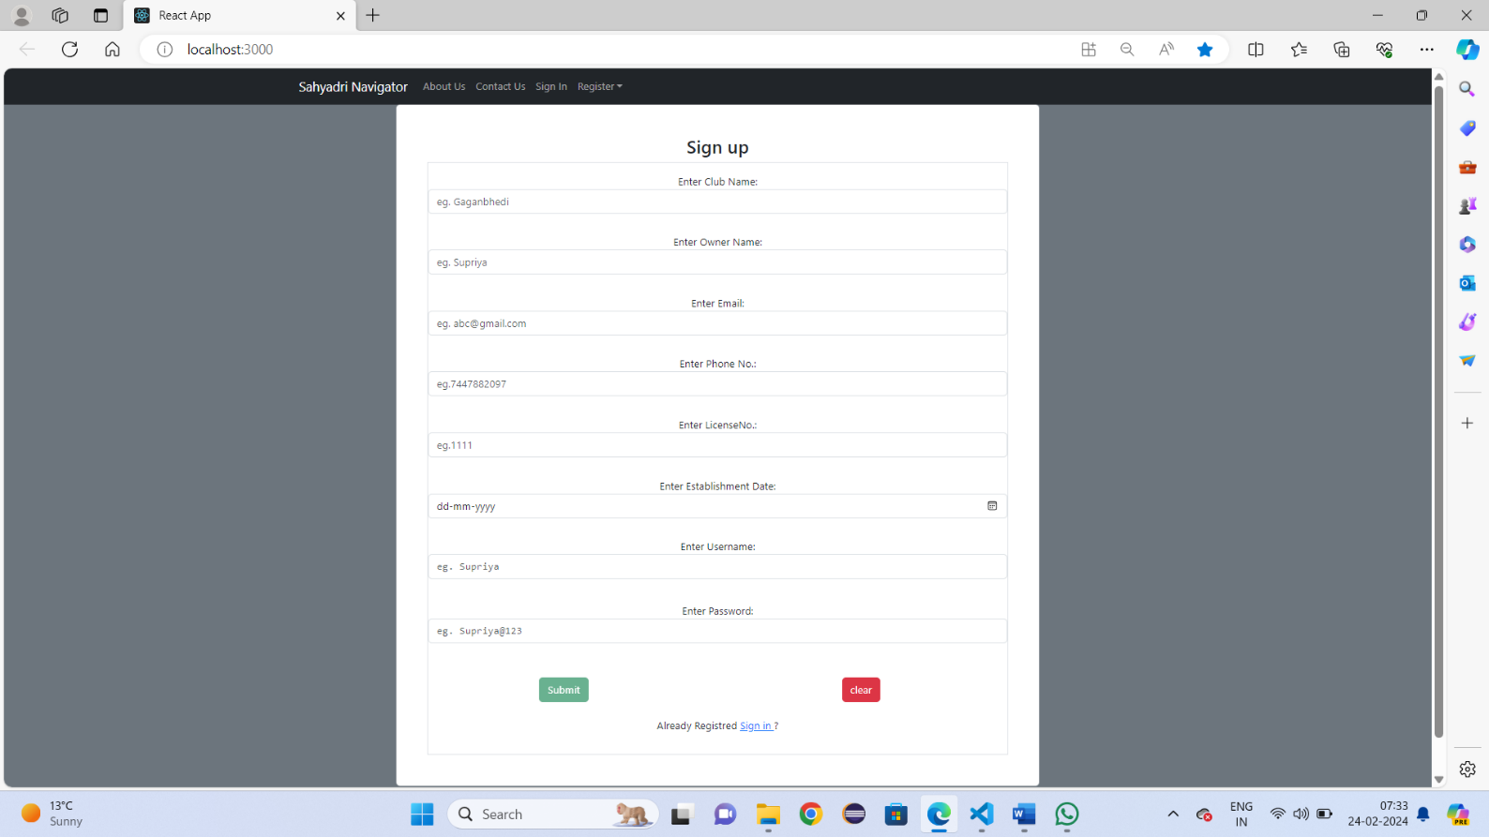

Login form for Admin,Trekker and Trkking club

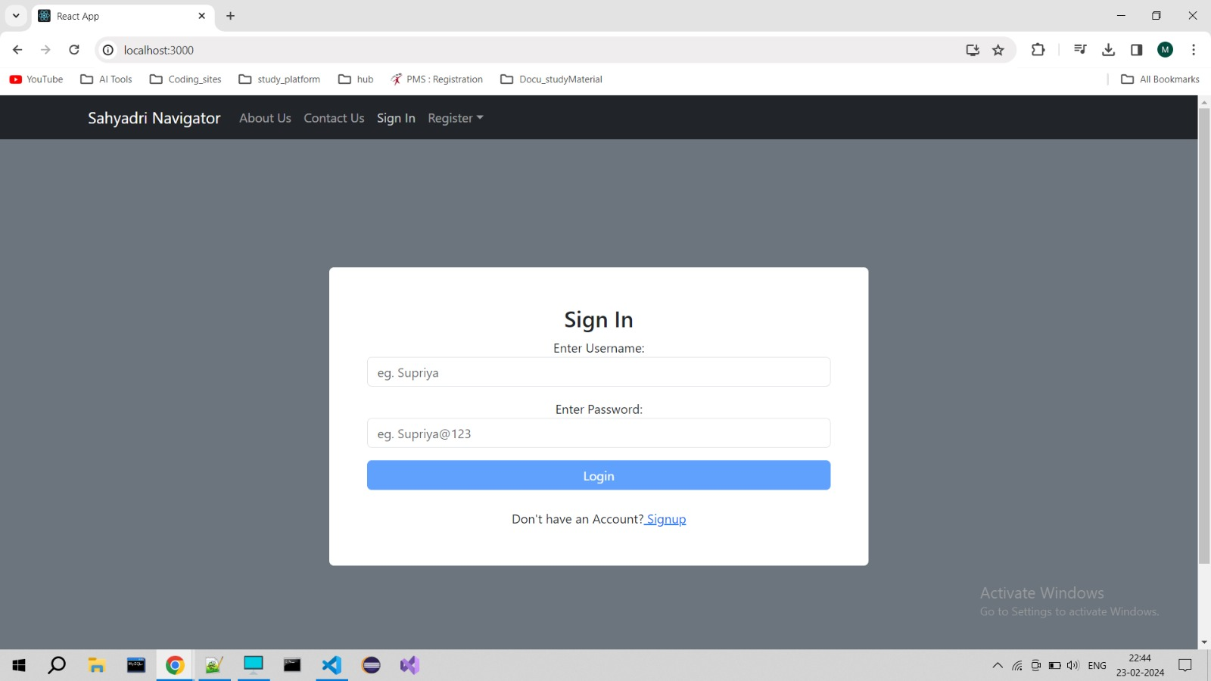

**8.2 Admin Home Page:**

Admin approve and delete the Trekking club

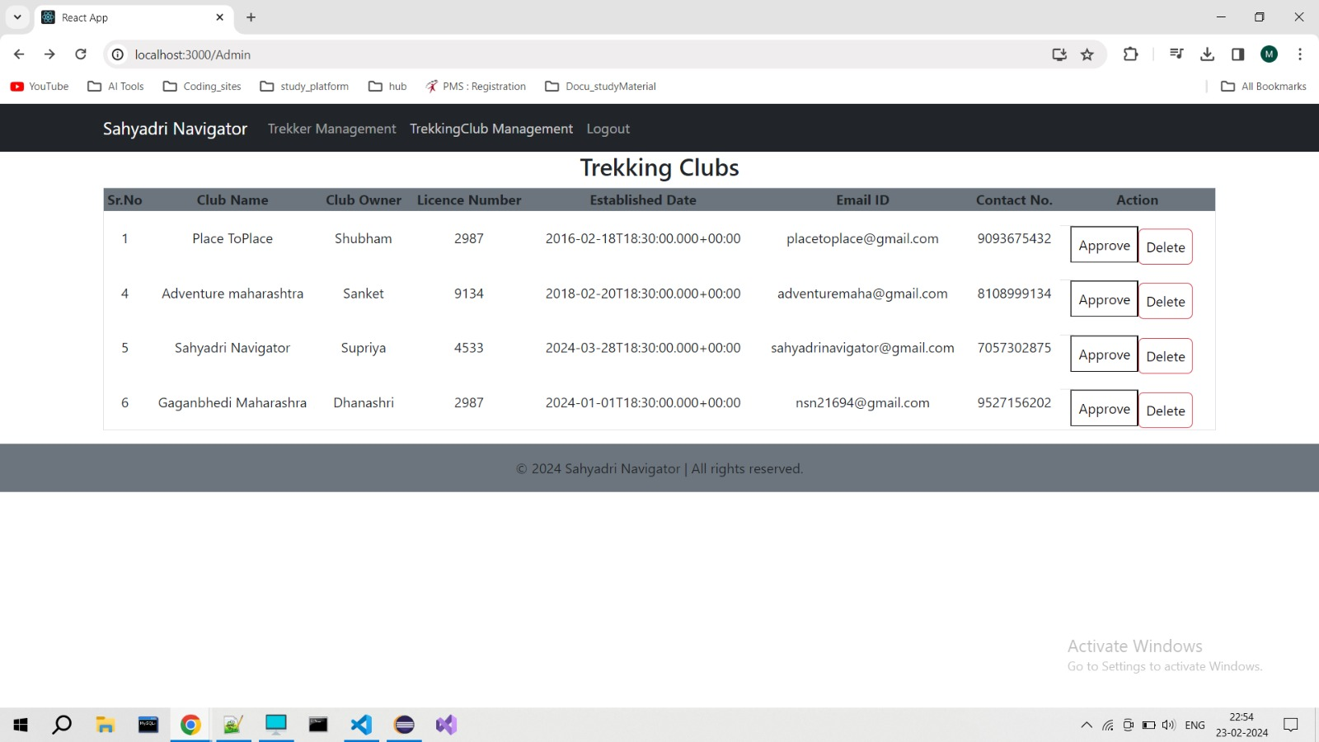

Admin approve the Trekking Club according to the information provided by them at the time

of registration.

Admin can delete the Trekker.

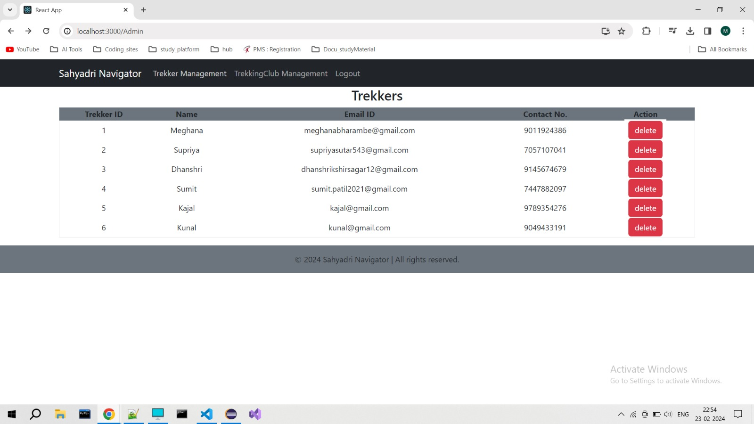

**8.3 Trekker Page**

Trekker can see the upcoming treks and can Book the treks,can check there their booked treks.

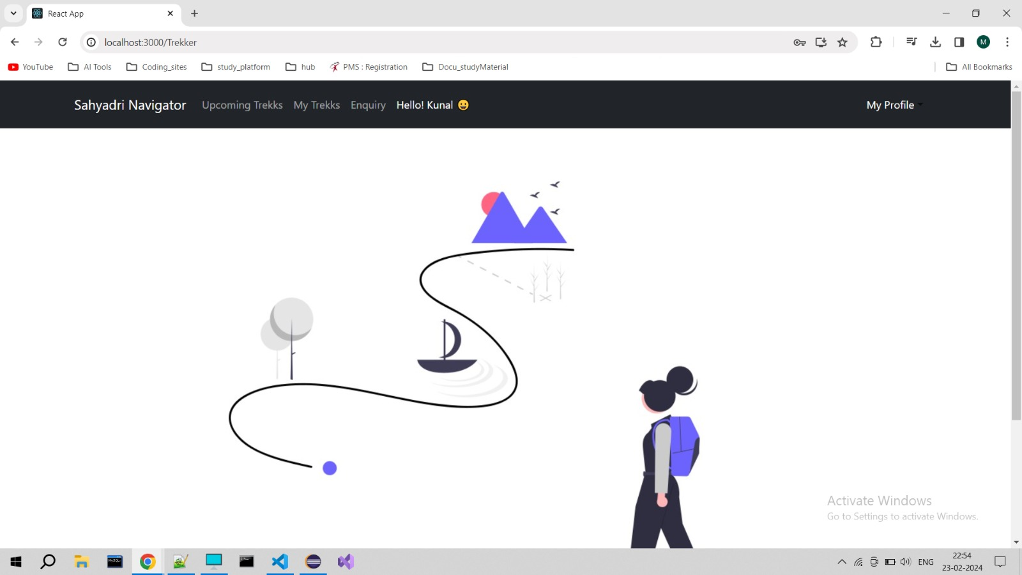

On this page artist can Book their Trekk:

**8.4 Trekking ClubPage**

Home Page:



Trekking club can add the upcoming trek.

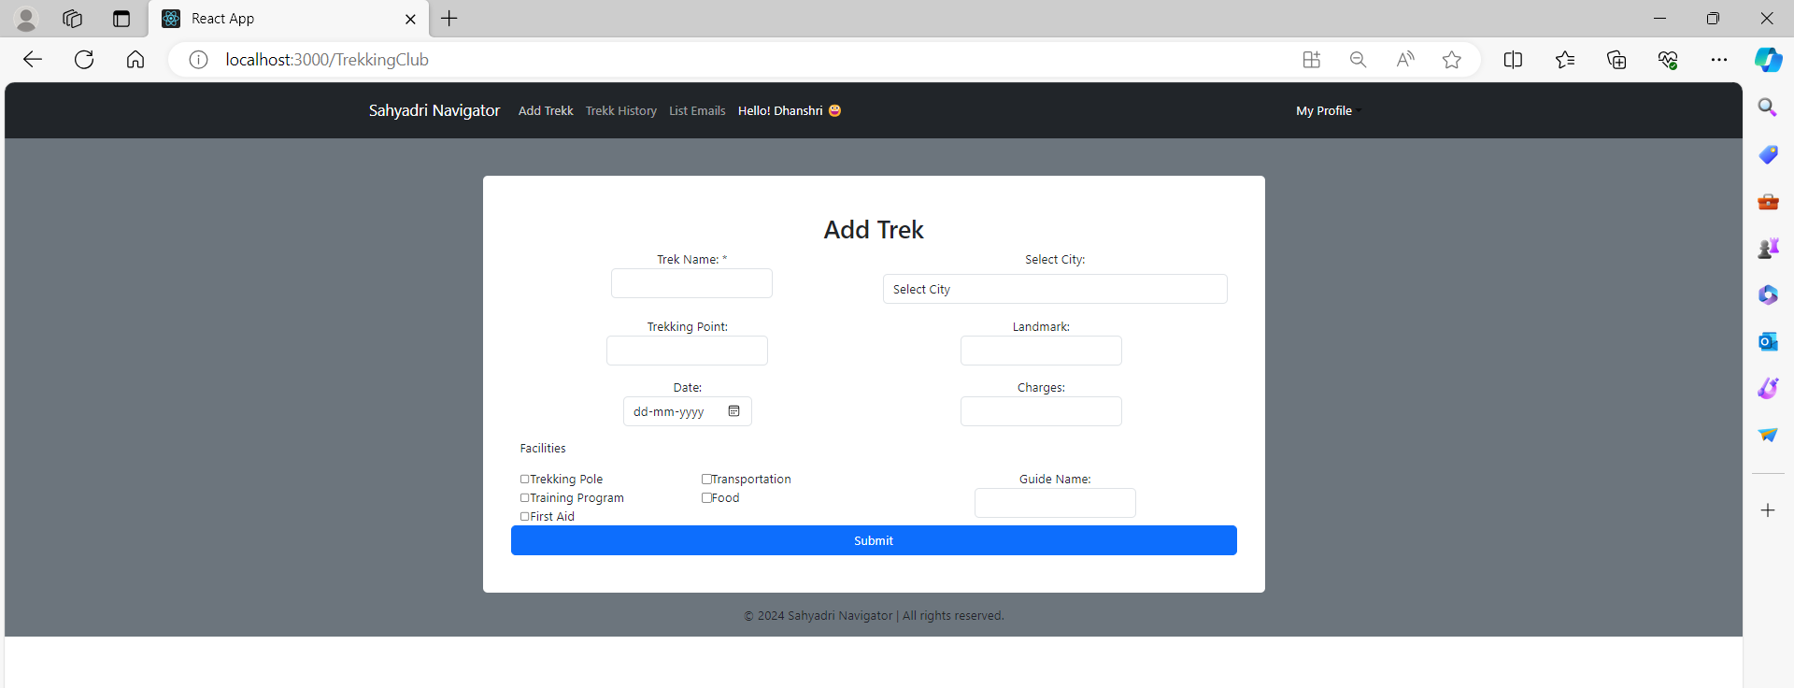

Trekking club can see all the Trekker history:

**9. CONCLUSION AND FUTURE SCOPE**

Sahyadri Navigator provides better platform for Trekker to showcase their interest and exploring their dream. And Trekker club also get the apportunity to get in touch with the trekkers and can compete with the other clubs.

Our System provides a very user-friendly platform where Trekker can easily book the trek with the help of images provided by the Trekking Club.